Google Auth (OAuth2 login with Google) in Spring Boot microservices uses Spring Security's OAuth2 client for secure, delegated authentication, avoiding custom user storage. Integration adds dedicated config classes and properties, with minimal changes to existing folders like controller and config.
Setup Dependencies
Add spring-boot-starter-oauth2-client and spring-boot-starter-security to pom.xml. Obtain Google Client ID/Secret from Google Cloud Console (APIs & Services > Credentials), set redirect URI to http://localhost:8080/login/oauth2/code/google.
Properties Configuration
In src/main/resources/application.yml (or properties), define under spring.security.oauth2.client.registration.google with client-id and client-secret. Profiles like application-dev.yml handle env-specific creds securely.
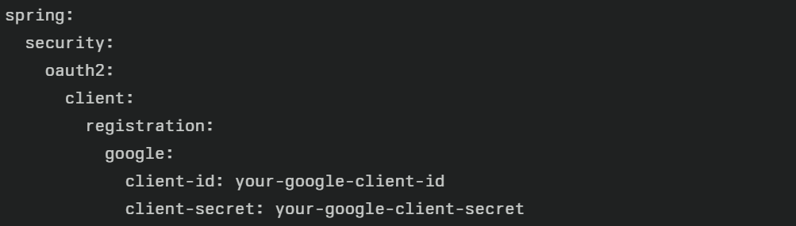
Config Package:
Create SecurityConfig.java in config/ with @EnableWebSecurity and @Configuration. Defines SecurityFilterChain bean to enable .oauth2Login(), permit public paths (/, /login), and secure others. Customizes logout, CSRF via cookies.
Example:
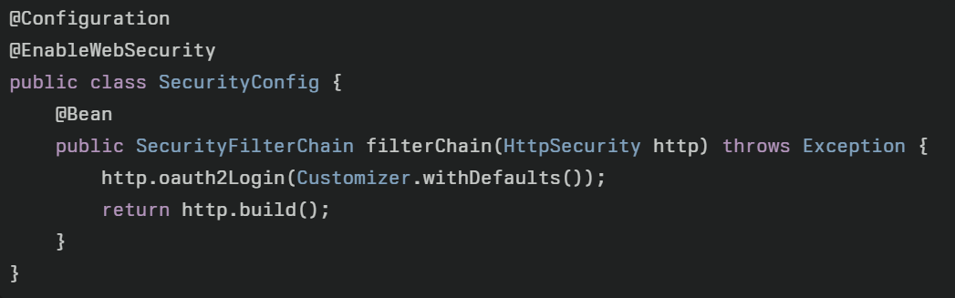
Controller Package:
Add optional endpoints like /login or /user in controllers (e.g., AuthController.java with @RestController). Use @GetMapping("/user") injecting OAuth2User or OidcUser to fetch claims (e.g., principal.getAttribute("email")). Home page links to /oauth2/authorization/google trigger flow.

